Academic and

Creative

Enrichment...

“ACE” supply list

* 1/2-inch binder with clear view cover (for inserting paper)

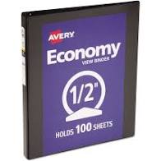

* 1 Pack of colored copy paper

